1) Write a program that demonstrates widening conversion from int to double and prints the result.

public class Q1 {  
 public static void main(String[] args) {  
 int integer = 1937;  
 double doub = integer;  
 System.*out*.println(doub);  
 }  
}

Output:



2) Create a program that demonstrates narrowing conversion from double to int and prints the result.

public class Q2 {  
 public static void main(String[] args) {  
 double doub = 1204.44;  
 int integer = (int)doub;  
 System.*out*.println(integer);  
 }  
}

Output:

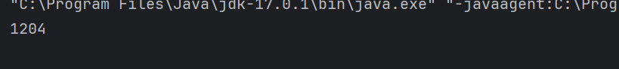

3) Write a program that performs arithmetic operations involving different data types (int, double, float) and observes how Java handles widening conversions automatically.

public class Q3 {  
 public static void main(String[] args) {  
 int intValue = 10;  
 float floatValue = 15.5f;  
 double doubleValue = 20.75;  
  
 float result1 = intValue + floatValue;  
 System.*out*.println("Result of int + float: " + result1);  
  
 double result2 = floatValue + doubleValue;  
 System.*out*.println("Result of float + double: " + result2);  
  
 double result3 = intValue + doubleValue;  
 System.*out*.println("Result of int + double: " + result3);  
  
 double result4 = intValue + floatValue + doubleValue;  
 System.*out*.println("Result of int + float + double: " + result4);  
 }  
}

Output:

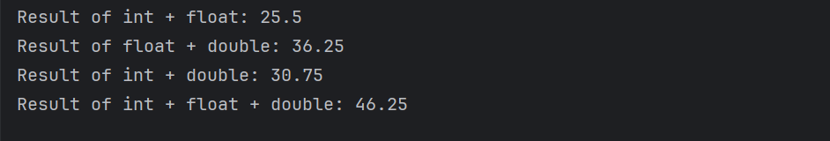

4) Write a Program that demonstrates widening conversion from int to (double,float, boolean, string) and prints the result.

public class Q4 {  
 public static void main(String[] args) {  
 int a = 1234;  
// int to double  
 double doubl = a;  
 System.*out*.println("int to double: "+doubl);  
// int to float  
 float flot = a;  
 System.*out*.println("int to float: "+flot);  
  
// int to boolean  
// boolean bool = a; // compile time error;  
  
// int to String  
 String str = Integer.*toString*(a);  
 System.*out*.println("int to String: "+str);  
 }  
  
}

Output:

